**Tracking Exercise**

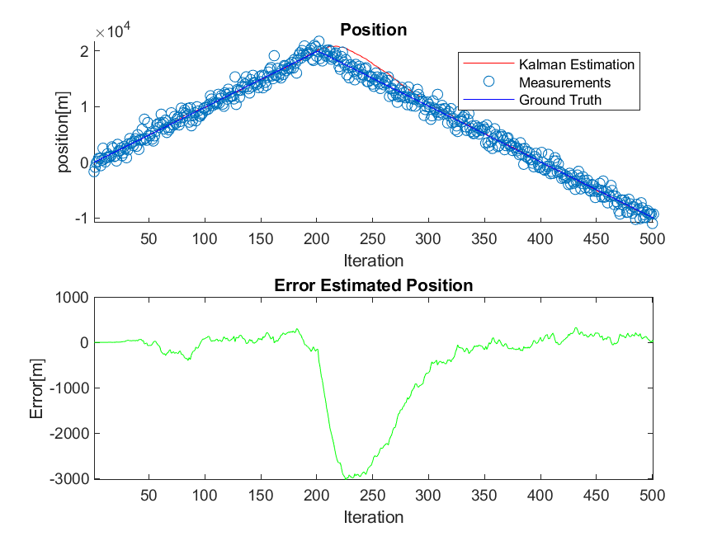

We can see here that the filter estimates the position quite accurately whilst the target moves in a constant velocity, and the sudden change in velocity leads to a peak in the estimation error, which over time reduces as the target continues to move with constant speed.

We can see the error peak in the position plot as well, the filter strays away as the direction of velocity changes and in about ~100 iterations stabilizes again around the ground truth.

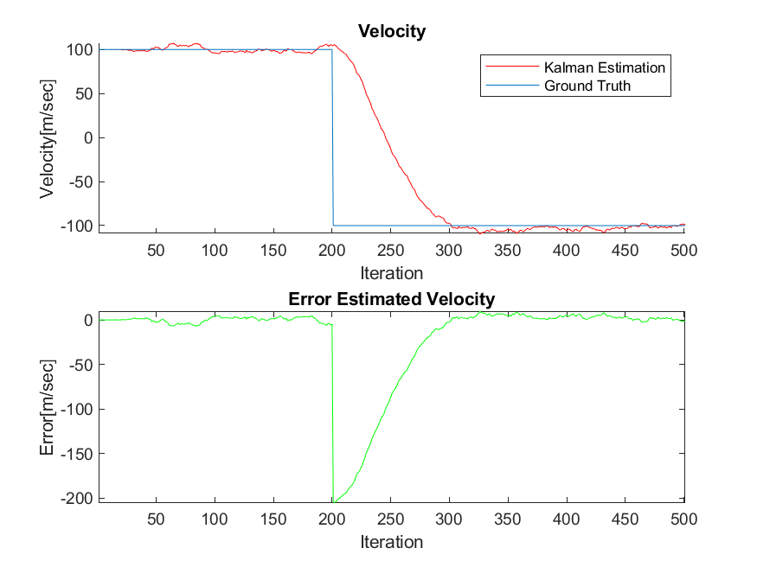

Here we can see more clearly the change in velocity, and how the filter takes a while to estimate the correct value (with a much smaller error margin). Similarly to the position error plot we see that the velocity error jumps when the target changes direction, and it takes the filter around 100 iterations to go back to the previous state in which the estimation error is and order of magnitude smaller.

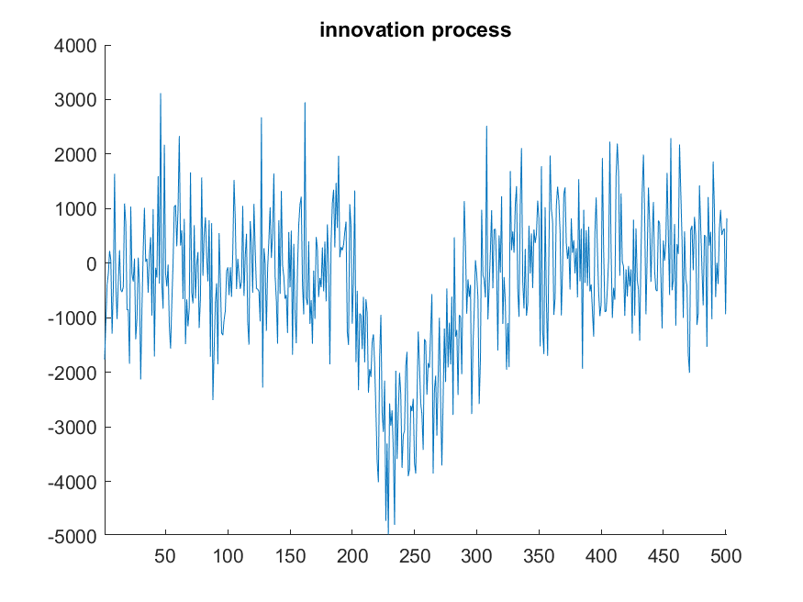

Based on the innovation process plot we obtained from the simulation we speculate that the process is not white. If the process was white the noise would be around zero throughout the whole process, but we see that the expected value of the innovation process changes around the 200th iteration (due to the sudden change in velocity).

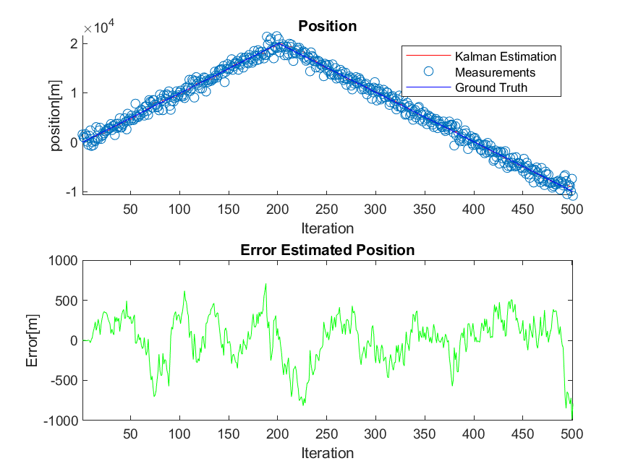

We decided to increase the value of $σ_{w}$ so that the filter assumes a more noisy environment.

We can see that the filter estimates slightly worse along the constant velocity, but it doesn’t overshoot once the target changes direction. This is due to that fact that the filter ‘assumes’ that the physical model is one with more variant noise, and thus trusts the measurement more than the prediction.

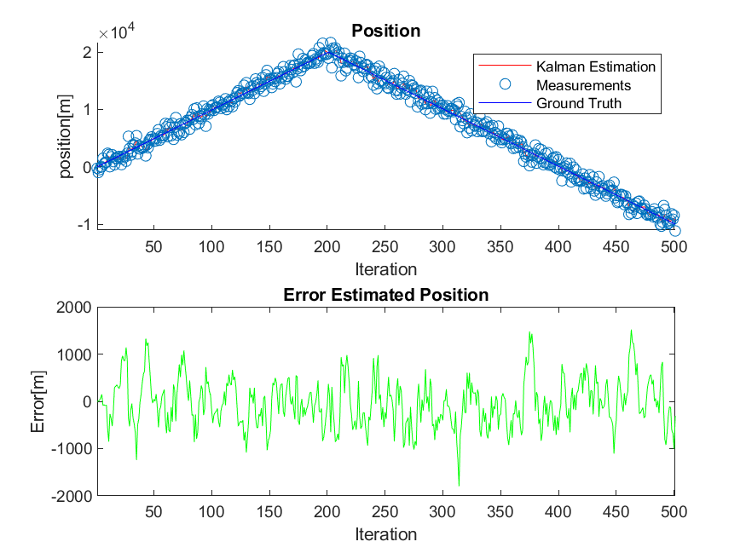By reducing the filter parameter of $σ_{v}$ the filter assumes less noise in the measurements, and so the estimation relies more on the measurements (similarly to increasing the variance of the process noise).